**Lampiran Praktikum 10**

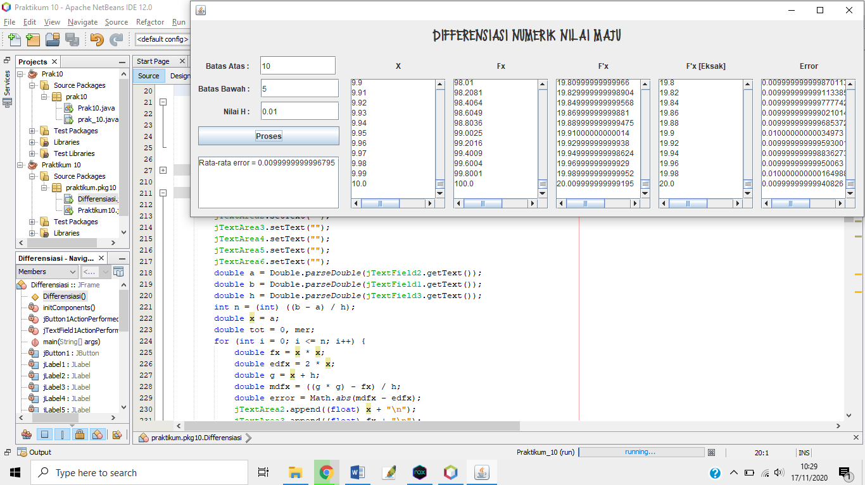

Listing Code :

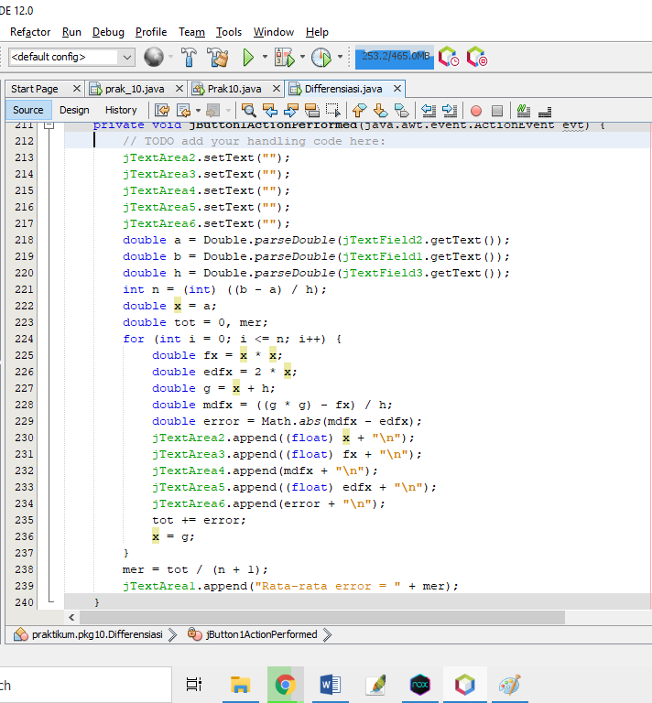

Tampilan GUI :

